|  |  |  |  |  |  |
| --- | --- | --- | --- | --- | --- |
| Gini net *t-1* | 0.4329*** | 0.8228*** | 0.4898*** | 0.7856*** | 0.4880*** |
|  | 0.0949 | 0.0363 | 0.0836 | 0.0543 | 0.1058 |
| GDP growth | -0.5453* | -0.1361 | -0.3542 | -0.1281 | -0.5439 |
|  | 0.2583 | 0.1216 | 0.2533 | -0.0997 | 0.2623 |
| Government exp. | 0.0023 | -0.1635** | -0.1008 | -0.1899** | -0.0268 |
|  | 0.0743 | 0.0472 | 0.0697 | -0.0633 | 0.0835 |
| Trade | 0.0392 | -0.0134 | 0.0760* | -0.0117 | 0.0303 |
|  | 0.0392 | 0.0112 | 0.0353 | -0.0127 | 0.0371 |
| Employment rate | -0.3367* | -0.0752*** | -0.1266 | -0.0860* | -0.2845*** |
|  | 0.0568 | 0.0225 | 0.0667 | -0.0087 | 0.0538 |
| Secondary education | -0.0336 | 0.006 | -0.0744 | 0.0367* | -0.0271 |
|  | 0.0335 | 0.0105 | 0.043 | -0.0184 | 0.035 |
| Transfers in cash | -0.1867* |  |  |  |  |
|  | 0.0376 |  |  |  |  |
| Transfers in kind | | -0.0112* |  |  |  |
|  |  | 0.0041 |  |  |  |
| Health expenditure | |  | -0.1142* |  |  |
|  |  |  | 0.0482 |  |  |
| Education expenditure | |  |  | 0.0367* |  |
|  |  |  |  | 0.0184 |  |
| Pensions |  |  |  |  | -0.1687* |
|  |  |  |  |  | 0.0561 |
| Observations | 133 | 128 | 130 | 130 | 126 |
| Hansen p-value | 0.03 | 0.04 | 0.03 | 0.04 | 0.03 |

Table 1. GMM model

*** p < 0.001; ** p < 0.01; * p < 0.05

Table 1. GMM model

|  |  |  |  |  |
| --- | --- | --- | --- | --- |
| Gini net *t-1* | 0.5765*** | 0.4658*** | 0.4754*** | 0.7681*** |
|  | 0.104 | 0.0552 | 0.0776 | 0.0507 |
| GDP growth | -0.3242 | -0.1333 | -0.4284 | -0.2359 |
|  | 0.2424 | 0.2018 | 0.2242 | 0.1328 |
| Government exp. | -0.2252* | -0.1680* | -0.1675* | -0.2069* |
|  | 0.0707 | 0.0544 | 0.0668 | 0.0392 |
| Trade | 0.042 | 0.0608* | 0.043 | -0.0028 |
|  | 0.0359 | 0.0194 | 0.026 | 0.0114 |
| Employment rate | -0.2810* | -0.2203* | -0.1394* | -0.0677* |
|  | 0.0834 | 0.0845 | 0.0562 | 0.024 |
| Secondary education | -0.0391 | 0.0839* | 0.1093*** | -0.0018 |
|  | 0.0368 | 0.0284 | 0.0284 | 0.0774 |
| Property taxes | 0.3000*** |  |  |  |
|  | 0.123 |  |  |  |
| Indirect taxes | | 0.0839** |  |  |
|  |  | 0.0284 |  |  |
| Income tax |  |  | -0.8783*** |  |
|  |  |  | 0.4141 |  |
| Progressitvity index | |  | 0.0350 |  |
|  |  |  | 0.048 |  |
| Income tax*Prog. Ind. | |  | -0.8470* |  |
|  |  |  | 0.3454 |  |
| R&D (% GDP) | |  |  | -0.1801* |
|  |  |  |  | 0.0774 |
| Savings (% GDP) | |  |  | -0.0546*** |
|  |  |  |  | 0.0164 |
| R&D*Savings | |  |  | 0.1354* |
|  |  |  |  | 0.0555 |
| Observations | 134 | 120 | 133 | 128 |
| Hansen p-value | 0.03 | 0.03 | 0.03 | 0.04 |

*** p < 0.001; ** p < 0.01; * p < 0.05

**Impulse Responses on Gini net by Local Projections**

**Fig. 1 Education expenditure**

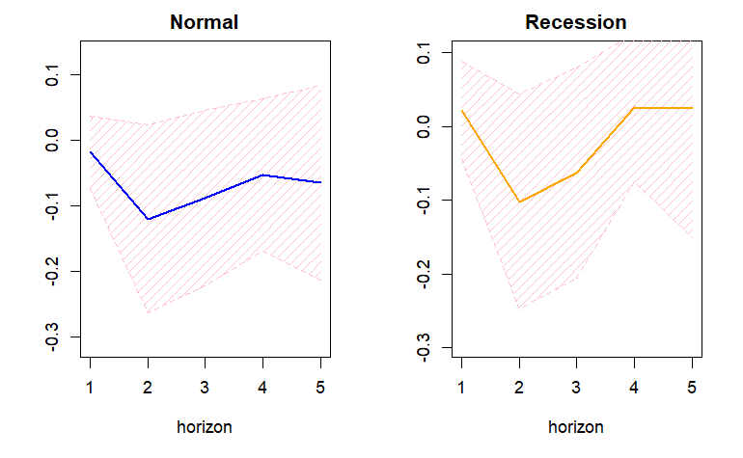

**Fig. 2 Health expenditure**

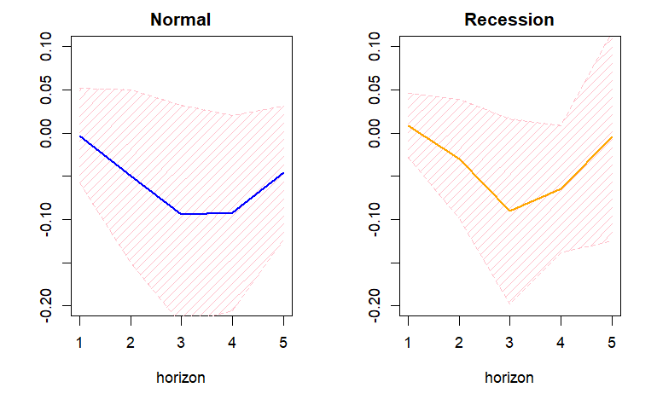

**Fig. 3. Transfers in kind**

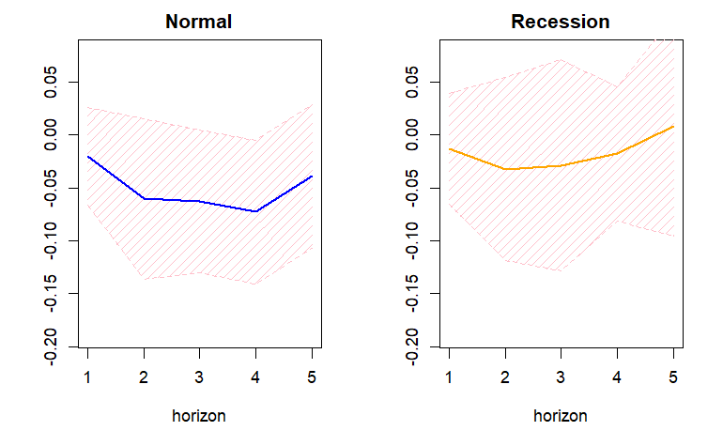

**Fig. 4. Transfers in cash**

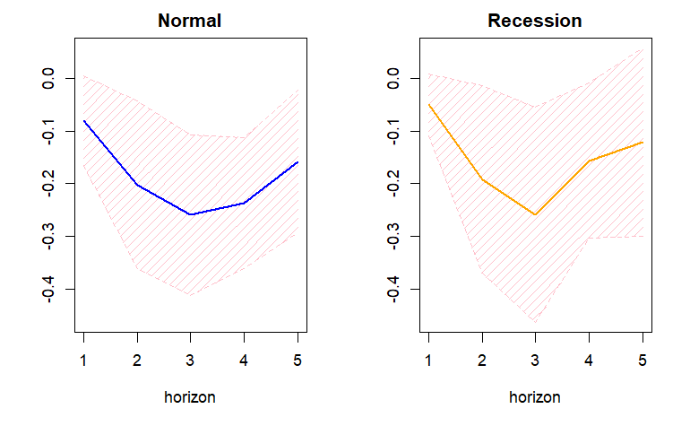

**Fig. 5. Pensions (Social protection)**

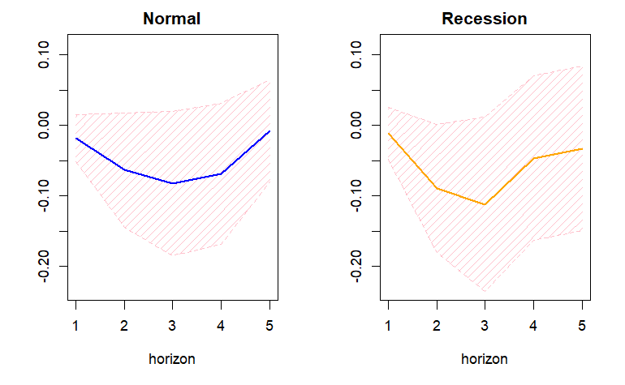

**Fig. 6. Property taxes**

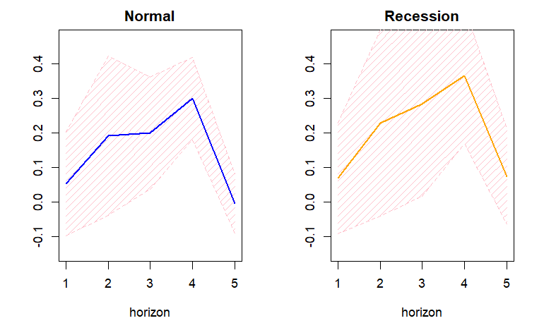

**Fig. 7. Progressivity of Personal income tax**

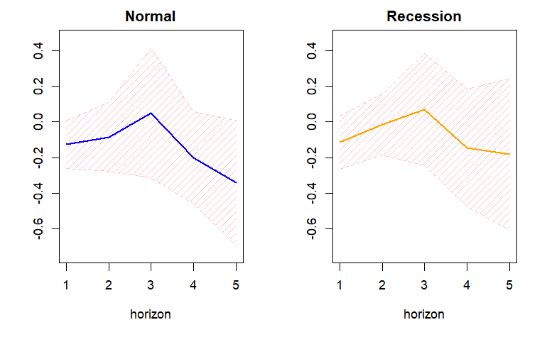

**Fig. 8. Indirect taxes**

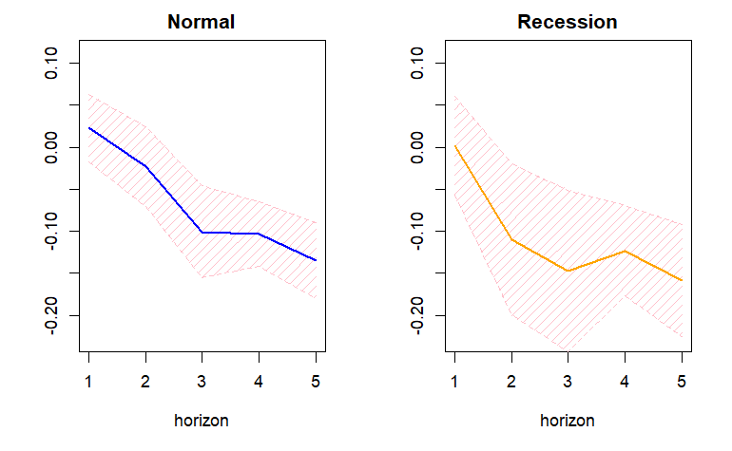

**Fig. 9. R&D expenditure (% GDP)**

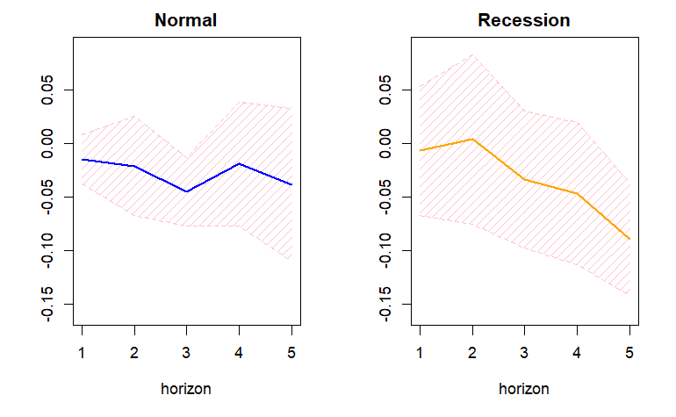

**Fig. 10. Savings (% GDP)**

